**Study Title:**

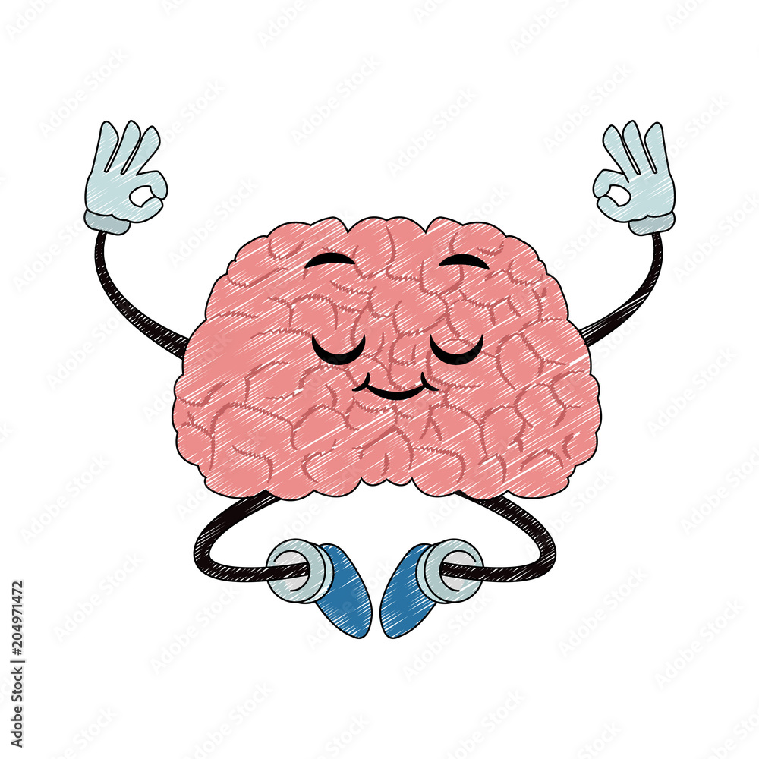**Shapes and Shocks: Learning & Attention Games**

**(2022/3539, Rowlands)**

Principal Investigator: Dr Michael C. Anderson

Researcher(s): Molly Rowlands

PRE/NRES Code: PRE.2019.041

You’re invited to take part in the Shapes and Shocks experiment. Before you decide whether to participate it is important that you understand why the research is being done and what it will involve. Please take time to read the following information and ask any questions that may arise!

**What is the purpose of this study?**

We are interested in understanding how we learn to link events together in our environment. Particularly, how do we link events together that are unpleasant? An example of forming such links might be learning not to touch a stove when it’s turned on and too hot, or learning to fear dogs if we had a scary experience in our childhood. We are interested in these learning processes of linking unpleasant events together, and how this interacts with your general ability to pay attention. To test these processes, you will complete a series of tasks on the computer.

**What is involved?**

In this study, you will be asked to engage in a number of games/tasks on the computer in-person with an experimenter. These games/tasks will be mini attention and learning games. One of these games will include learning links between various shapes and electric shocks.

These electric shocks will be placed on the wrist, are non-harmful, and non-painful. You will have a chance to experience the shock before proceeding with the rest of the study, so that you can decide whether you’d like to continue. Importantly, the shock levels will be individually tailored by you prior to the experiment, so that you can choose a shock level that is *highly annoying but not painful*.

Other mini tasks/games will rely on your attention and will involve neutral, non-emotional pictures and games. At the end of this computer task, you will complete a set of questionnaires asking about your mood and thinking patterns. The entire experiment will take approximately 1.5 hours.

If have any questions, please do let me know!

Molly Rowlands

Email: molly.rowlands@mrc-cbu.cam.ac.uk